Learn to Walk a Showjumping Course
Wednesday 19th August 2015
At Mullingar Equestrian Centre
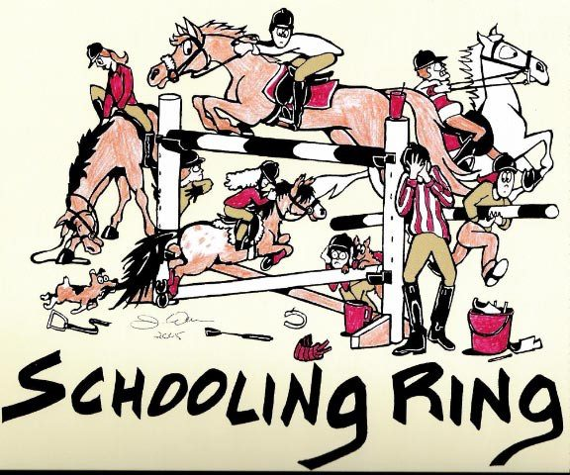  128 and 138 riders at 5 pm 148 riders at 6pm Horse riders at 7pm |  | For ALL members of the LEINSTER DEVELOPMENT SQUAD and other interested members  Coach  Ian Fearon  NO HORSES /PONIES REQUIRED  To confirm your attendance please phone Rose Rice on 086 0444068

